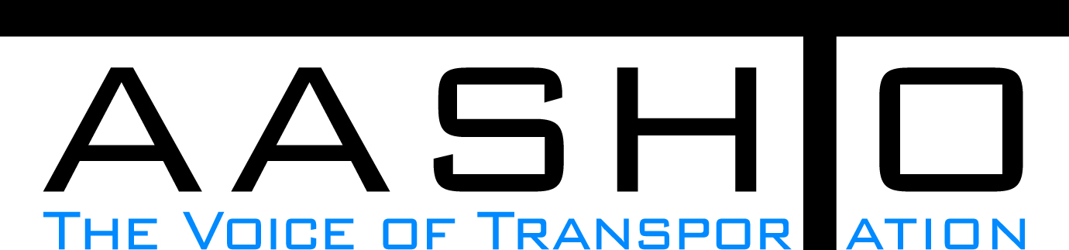Domestic Scan Proposal Form
AASHTO is soliciting topic proposals for a Calendar Year 2013 US Domestic Scan Program (NCHRP Panel 20-68A). Each selected scan topic will be investigated through site visits to three to six locations for approximately a two week period or less (type 1), by webinar (type 2) or peer exchange (type 3) conducted by a group of eight to 12 transportation professionals with expertise in the selected topic area. Proposed topics should meet the following criteria:
- Address an important and timely need for information by transportation agencies;
- Are of interest to a broad national spectrum of people and agencies;
- Are complex and also “hands-on,” meaning they lend themselves particularly well to exploration through on-site visits; and
- Are sufficiently focused that the tour participants are able to investigate and understand key issues in the limited time available on the tour.
This form is designed to collect the full length of your proposal. Sections requiring essays have unlimited space for you to use. Contact information has some limited text. Use your TAB key to advance to the area where you need to complete information.
Proposals should be returned no later than OCTOBER 15, 2012.
Proposal Contact Information
Name | Matthew Chynoweth | Address | 6333 Old Lansing Road
Title | Engineer Of Bridge Field Services | E-mail | chynowethm@michigan.gov
Member Department | Yes | Telephone number | 517-322-3322
AASHTO Committee |  | Date of submission | 10/1/2012

Title of Proposed Scan

Scan Of Design And Construction Of Light Standard, Traffic Signal Mast Arms, Sign Support Structures, And DMS Support Structures and other Ancillary Structures

Problem Statement (What topic is to be examined? What drives the need for the scan? Why now?)
Topics to be scanned are states design and construction practices for light standard, traffic signal mast arms, sign support structures, and DMS support structures. Michigan DOT has had a rash of light standards, and DMS sign support issues lately with respect to poor design details, questionable materials, inadequate installation, poor bolting, poor welding, and fatigue issues. There is also a construction inspection piece, in which more emphasis is needed on proper inspection and acceptance. With the focus on asset management of all highway assets in the new MAP-21, Michigan DOT feels it necessary to investigate national best practices in the design, construction and maintenance of these ancillary structures.

Scan Scope (What specific subject areas are to be examined? Which cities and states might be visited? Which agencies/organizations (including specific departments or types of staff if applicable)?
Ancillary structure design details, construction inspection procedures, and life cycle maintenance.
Also focus on durability, and fatigue resistance of modern detials.
Cities visited should include major urban areas where freeway lighting, public lighting (on bridges), sign structures, and DMS support structures are frequenty used. State DOT structural and operational staff inclusion would be appropriate.

Anticipated Scan Results (What key information is to be gained? What information is to be shared after the scan? Who would the audience be for this information?)
Lessons learned, best practice, and maintainable details for ancillary structures. Provide information on asset management best practice, life cycle expectations, and rehab/repair options. All information will be shared with interested fabrication, structural, construction, and operations engineers.

Benefits Expected (Including potential impacts on current technology or procedures)
More constructable details, less prone to fatigue, and the proper inspection of fabrication, erection and management of these structures.

